Geometry: Unit 4, Lesson 4

- Point $\left(2, 5\right)$ is a vertex of an object on a coordinate plane. The object is reflected over the line $y=x$, and then rotated $90°$ clockwise around the origin. What is the coordinate of the point after the sequence of transformations?

$$(2, -5)$$
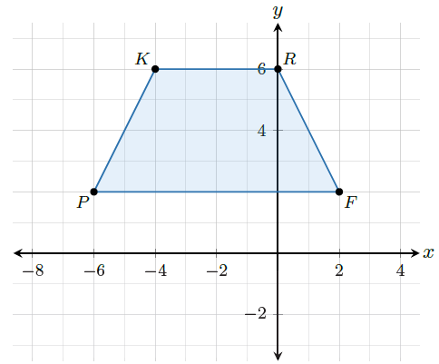

- Quadrilateral $PKRF$ is shown on a coordinate grid. What is the value of point $K'$ after a $180°$ clockwise rotation around the origin is performed on the quadrilateral?

$$(4, -6)$$
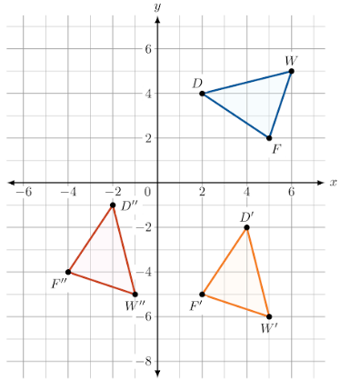
- Triangles $DWF$, $D'W'F'$ and $D''W''F''$ are shown on the coordinate grid. What sequence of transformations maps triangle $DWF$ onto triangle $D'W'F'$ and then onto triangle $D''W''F''$?

Rotation of $90°$ clockwise around the origin, and then a translation of $6$ units to the left and $1$ unit up

